**PHYS040C – PRE-LAB 05 – DC Electrical Circuits**

**Ivan Neto**

**Section 109**

1. Using the Power Law, $P=IV$, and Omh’s Law, $V=IR$, obtain an expression for the maximum current you can safely apply to a ¼ watt 3 $Ω$ resistor.

We can write the power law as $V=\frac{P}{I}$

If we plug this into Ohm’s Law, $V=IR→\frac{P}{I}=IR$

Now we solve for $I$:

$\frac{P}{I}=IR$

$P=I^{2}R$

$I^{2}=\frac{P}{R}$

$I=\sqrt{\frac{P}{R}}$

Plugging in the given values into this formula:

2. Bulbs A, B and C in the circuit diagram below are identical.

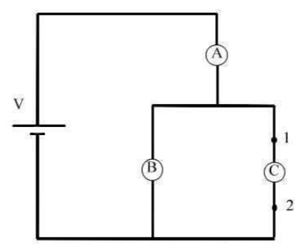

1. Rank in order, from most to least, the brightest of the three bulbs. Explain your reasoning.

Voltage across A:

$V_{A}=IR_{A}$

Voltage across B and C:

$V_{BC}=I{\left(\frac{1}{R_{B}}+\frac{1}{R_{C}}\right)}^{-1}=I{\left(\frac{R_{B}+R_{C}}{R_{B}R_{C}}\right)}^{-1}=I\left(\frac{R_{B}R_{C}}{R_{B}+R_{C}}\right)$

$\left(\frac{R_{B}R_{C}}{R_{B}+R_{C}}\right)>R_{A}$ because $R_{A}=R_{B}=R_{C}$, so $V_{BC}>V_{A}$

So $I_{B}=\frac{V_{BC}}{R_{B}}$, $I_{C}=\frac{V_{BC}}{R_{C}}$, and $I_{A}=\frac{V_{A}}{R_{C}}$. Since $V_{BC}>V_{A}$, $I_{B}=I_{C}>I_{A}$.

By power law $P=IV=I\left(IR\right)=I^{2}R$,

$P_{B}=I_{B}^{2}R_{B}$, $P_{C}=I_{C}^{2}R_{C}$, and $P_{A}=I_{A}^{2}R_{A}$. Since $I_{B}=I_{C}>I_{A} and R_{A}=R_{B}=R_{C}$, then

$P_{B}=P_{C}>P_{A}$. The power of a light bulb determines how bright it shines, and therefore in terms

of brightness, B = C > A.

1. Suppose an ideal wire (with zero resistance) is connected between points 1 and 2. What happens to each bulb? Does it get brighter, dimmer, or go out completely? Explain your reasoning for each bulb.

It seems that if we pass a wire from point 1 to point 2, we would be undoing the resistance that light C is providing. Therefore:

Bulb A:

* For this lightbulb, since we removed one of the resistors in the parallel component, resistor B is practically in series. Thus the total resistance of the circuit increases and thus since $P=IV=I^{2}R$, this bulb should become brighter.

Bulb B:

* Bulb B is not as if it was connected in series, so it should become brighter because the current is the same as in A, and not split by the junction.

Bulb C:

* This light should go out because now current passes through the wire instead of the resistor.